

Lebanese University
Faculty of Engineering III
Computer & Telecom. Department

_______________________________________

Education enhancer using AI
Supervisor: Dr. Mohammad Aoude
Presented by
Kawthar berjawi (6423)
&
Aya Mrad (6362)

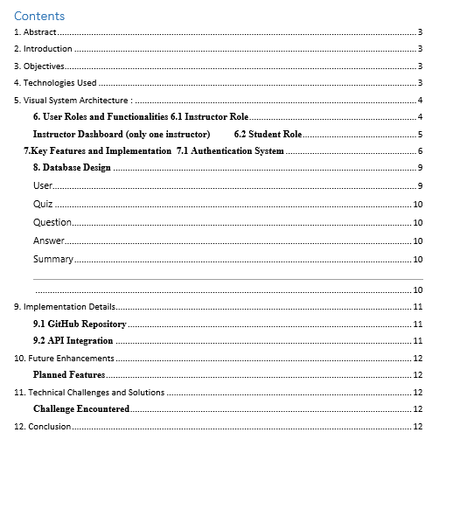

1. Abstract
This report presents a comprehensive overview of the educational platform project, designed to facilitate seamless interaction between instructors and students through a robust web-based interface. The platform addresses the growing need for efficient digital learning management systems that support both teaching and learning processes.
Project Overview:
- Platform Type: Web-based Educational Management System
- Primary Users: Instructors and Students
- Key Focus: Enhanced learning experience through technology integration

2. Introduction
The advancement of AI and web technologies has transformed educational tools. Education enhancer using AI is built to provide an intuitive interface for generating quizzes using AI engines, reducing manual effort while enhancing learning assessments' diversity and adaptability.

3. Objectives
- Develop a user-friendly and responsive quiz generation interface(manual and using ai).
- Integrate seamlessly with backend APIs serving AI-generated questions.
- Allow educators to generate, preview, and export quizzes efficiently.
- Deploy the application for public or institutional use with scalability in mind.

4. Technologies Used
Application stack and technologies | Purpose
React JS | Frontend framework for building dynamic user interfaces
Node JS (Backend) | API and server logic (handled in backend repo)
PostgreSQL | Database for storing quizzes and user data
Hugging Face Inference | Quiz generation using NLP models: Deepseek R1
Docker | Containerization and deployment consistency
GitHub | Version control and project management

During development | Purpose
Postman | for API testing and validation during development
Mailtrap | for email testing

Production technologies used for deployment | Purpose
Docker compose | Manage containers
Nginx | Web server & load balancer
AWS | Online servers
GitHub Actions | automated (CI/CD) pipelines

5. Visual System Architecture :
- Client Layer (web browsers)
- Presentation Layer (Nginx reverse proxy)
- Application Layer (Node.js/Express API)
- Data Access Layer (Type ORM)
- Data Layer (PostgreSQL + Redis)
- External Services (AWS, Email, Search, Monitoring)

6. User Roles and Functionalities
6.1 Instructor Role

Core Features:
- Dashboard Management: Comprehensive overview of courses, students, and activities
- Content Creation: Upload and manage quizes
- Student Management: Monitor student progress, grades, and participation
- Assessment Tools: Create quizzes, and grading systems

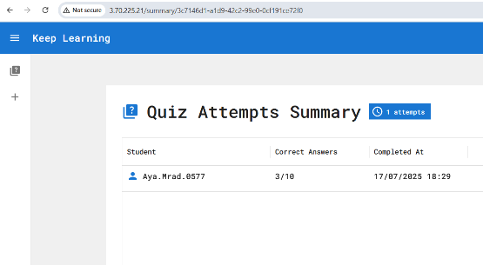
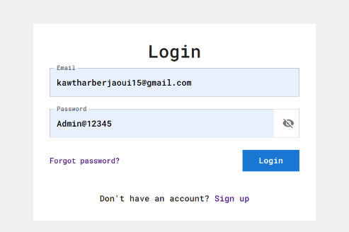
Instructor Dashboard (only one instructor)
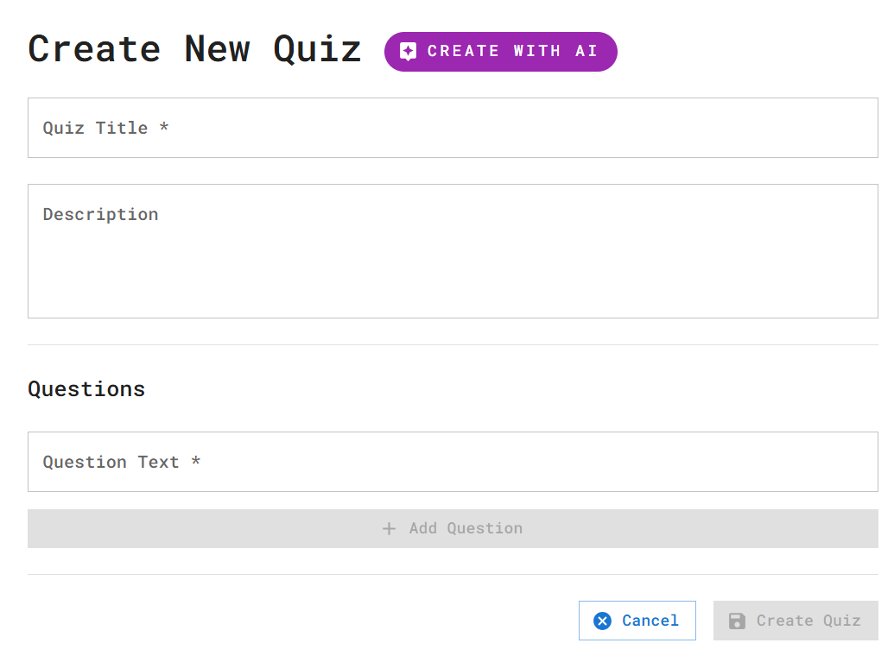
6.2 Student Role
The instructor can create a quiz using two ways: manually or using AI

Core Features:
- Personal Dashboard: View enrolled quizes, and grades with recommendation
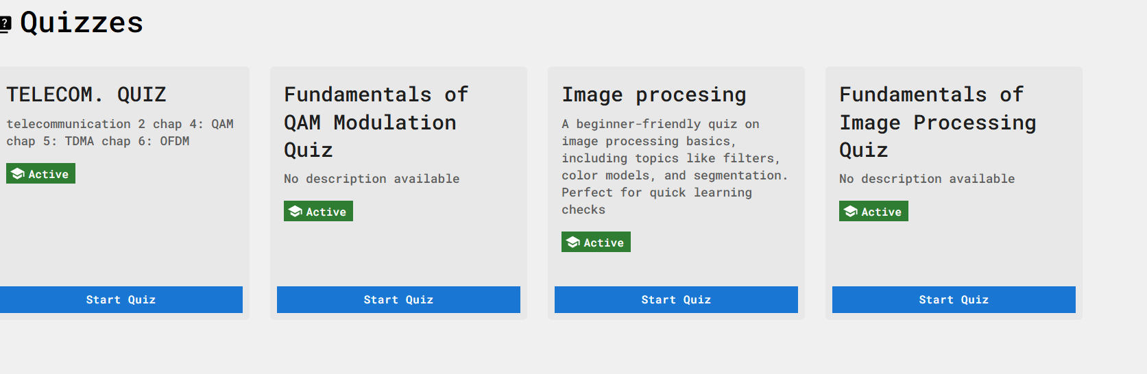
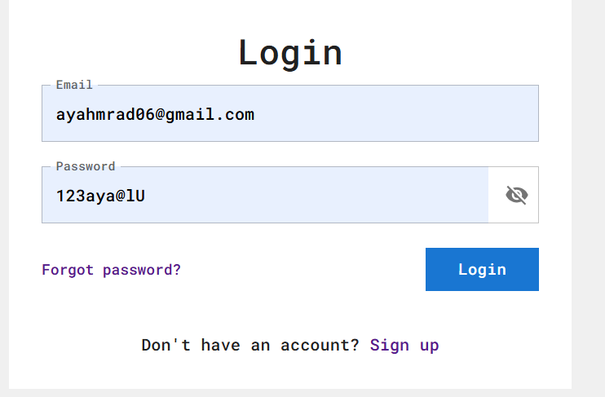
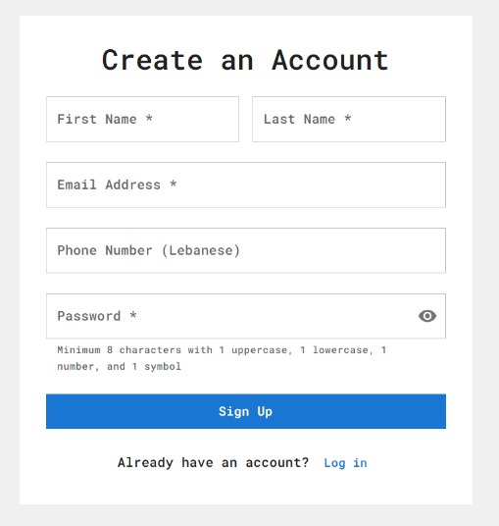
- Progress Tracking: Monitor personal academic progress and achievements
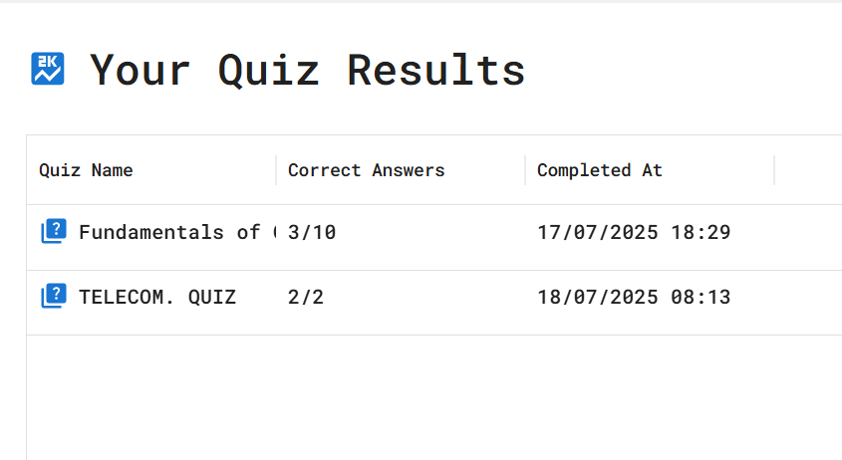
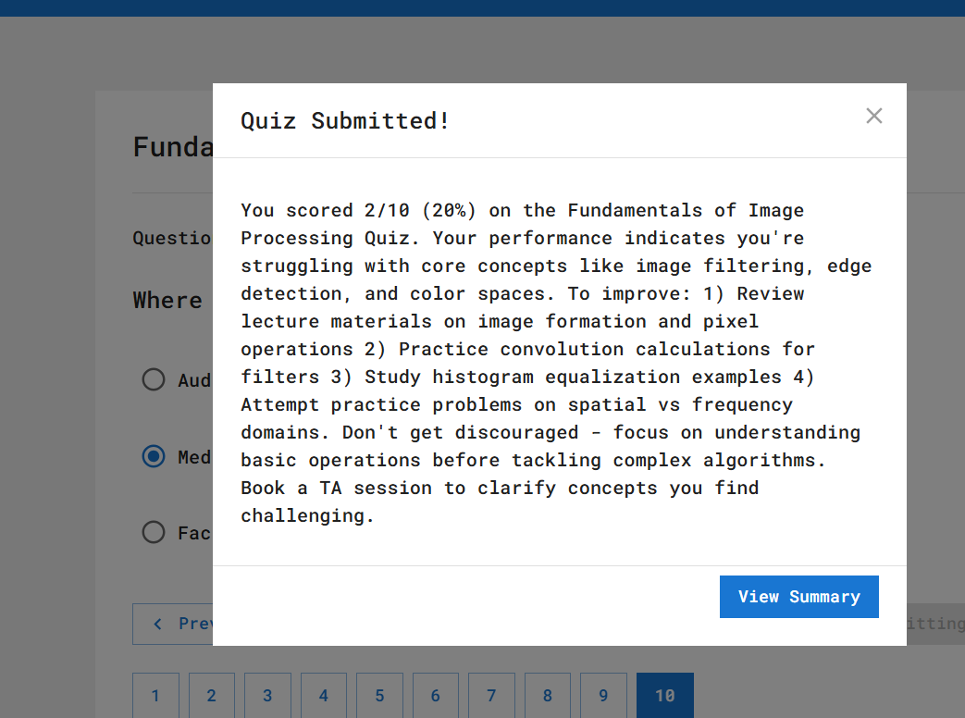

7.Key Features and Implementation
7.1 Authentication System

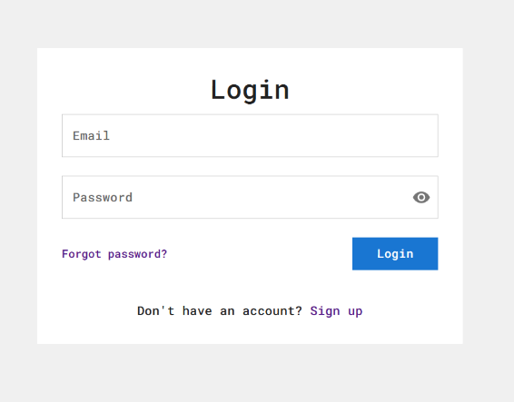
Login Interface:

1Implementation Details:
- Secure user authentication with password encryption
- Role-based access control (RBAC)
- Session management and timeout handling
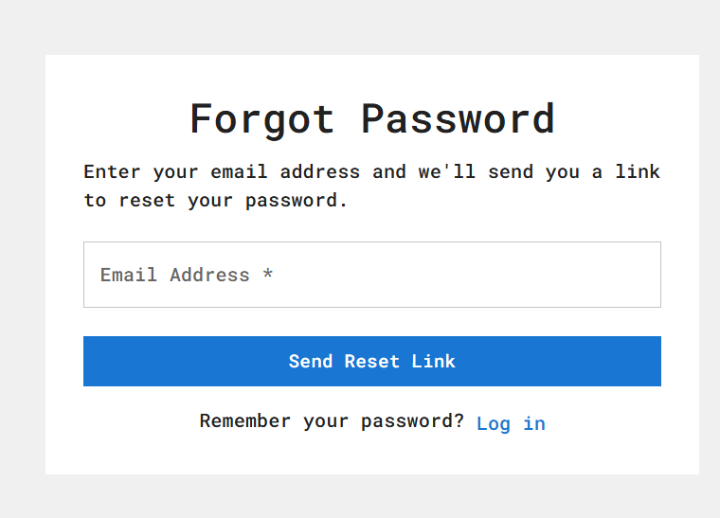
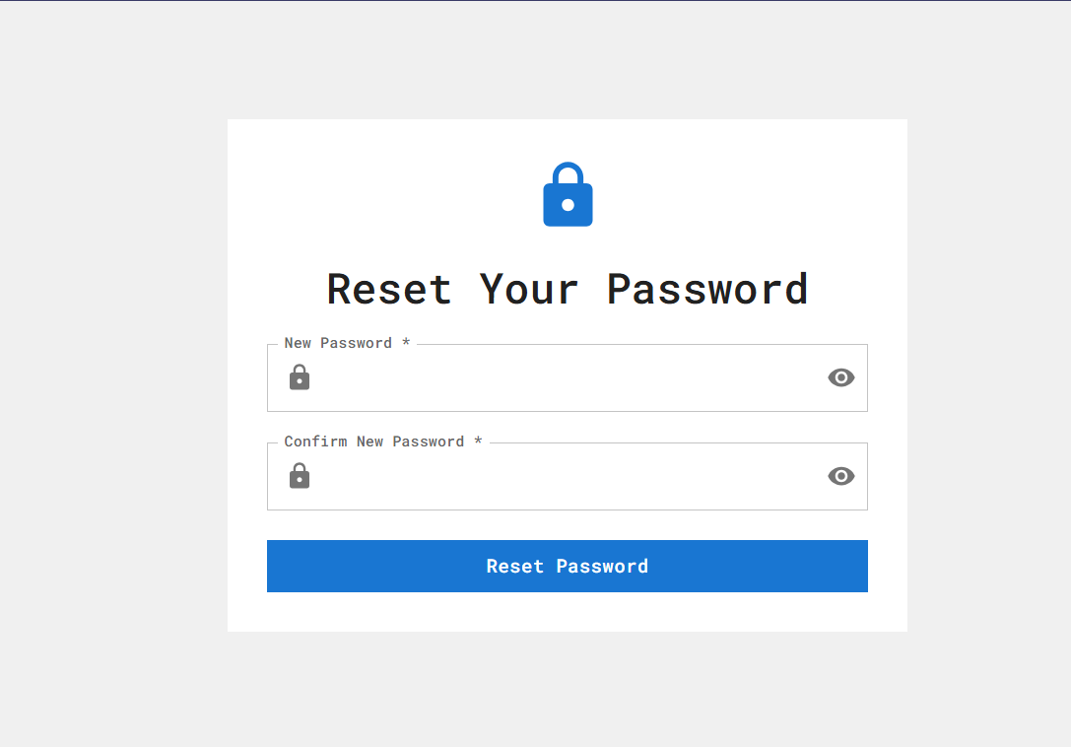
- Password recovery and reset functionality
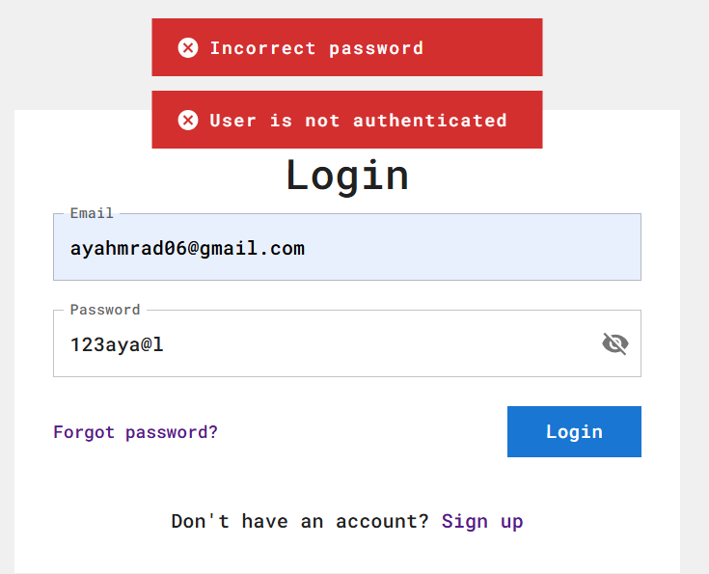

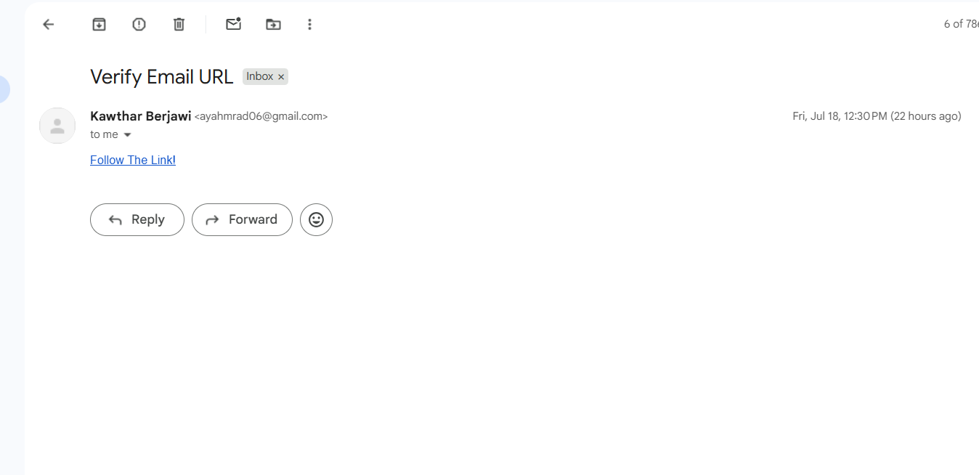

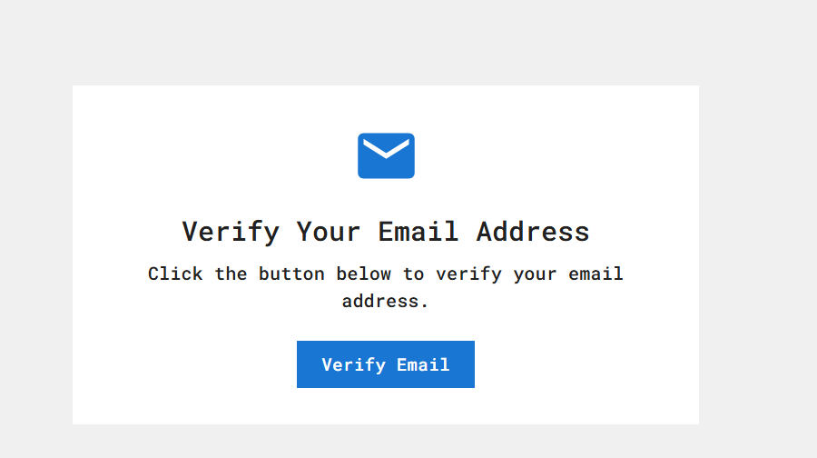
8. Database Design

User
- role (enum: "instructor" | "student")
- userName (varchar 100, unique)
- firstName (varchar 100)
- lastName (varchar 100)
- email (varchar 100)
- phoneNumber (char 8, nullable)
- password (char 60)
- isActivated (boolean, default: true)
- isVerified (boolean, default: false)
- passwordResetToken (varchar 100, nullable)
- passwordResetExpiry (timestamptz, nullable)
- emailVerificationToken (varchar 100, nullable)
- emailVerificationExpiry (timestamptz, nullable)
- createdQuizzes (OneToMany → Quiz)
- quizSummaries (OneToMany → Summary)

Quiz
- title (varchar 255)
- description (text, nullable)
- isActive (boolean, default: true)
- instructor (ManyToOne → User)
- questions (OneToMany → Question)
- summaries (OneToMany → Summary)

Question
- text (text)
- quiz (ManyToOne → Quiz)
- answers (OneToMany → Answer)

Answer
- text (text)
- isCorrect (boolean, default: false)
- question (ManyToOne → Question)

Summary
- correctAnswers (integer)
- totalQuestions (integer)
- quiz (ManyToOne → Quiz)
- student (ManyToOne → User)

9. Implementation Details

9.1 GitHub Repository
QuizGenFrontend GitHub Link

Key Files and Directories:
- /src/components – Reusable UI components
- /src/pages – Main pages (Home, QuizGenerator, Preview)
- /src/services – API service calls to backend endpoints
- App.js – Application entry with routing
- package.json – Project dependencies and scripts

9.2 API Integration
The frontend calls backend endpoints to:
- Send user input prompts
- Retrieve AI-generated quizzes with questions and choices.
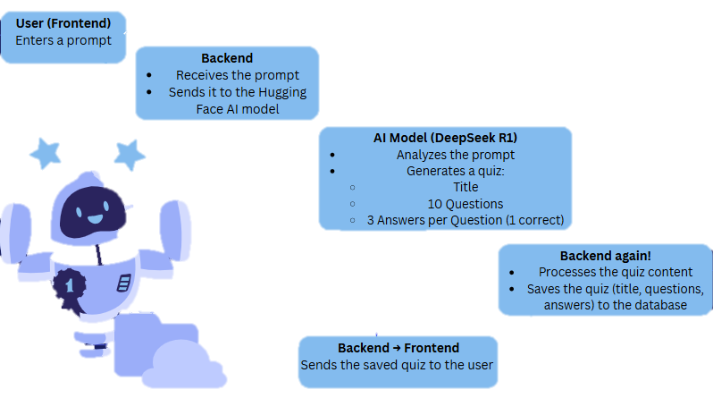
- Display results dynamically in the UI.

10. Future Enhancements

Planned Features
- Advanced Analytics: Detailed learning analytics dashboard
- Mobile Application: Native mobile app development
- Third-party Integrations: LMS integrations (Moodle, Blackboard)

11. Technical Challenges and Solutions

Challenge Encountered
Data Security: Protecting sensitive student and instructor information

12. Conclusion
The educational platform project successfully addresses the core requirements of modern digital learning environments. The system provides a comprehensive solution for both instructors and students, featuring intuitive interfaces, robust security measures, and scalable architecture.

